**Cole Thorpe**

**Lab Report 1**

**PHYS 2215**

**Matthew Pellegrini**

**Introduction**

In this lab we explored the properties of Newton’s Second Law of Motion. We are investigating the relation between force and acceleration through applying formulas and comparing them to real world experiments. We are provided with 2 masses to work with, a friction-less glider (M), and a falling mass (m). The acceleration (a) of the glider can be calculated through these masses and the force of gravity (g) in the provided equation,

$$a=g\frac{m}{m+M}$$

The given acceleration is a constant, no matter if the falling mass and glider are initially moving or not. Any other elements in the real world experiments are set up to simplify the procedure by mitigating friction, and any other masses that could cause inconsistencies. The software used compiles data as a quadratic curve where A, B and C are all constants,

$$x\left(t\right)={At}^{2}+Bt+C$$

Where $A=\frac{1}{2}a$ where a is acceleration, $B=V_{0}$ where $V_{0}$ is initial velocity, and $C=X_{0}$ where $X_{0}$ is initial position. The relation of A and a are apparent where, as previously stated $A=\frac{1}{2}a$, and $a=2A$. These equations are vital in gathering acceleration from the information our software provides. Throughout the real world experiment we will also calculate the uncertainty of the mean, deciding on the compatibility of our data to our calculated acceleration.

Exploring the properties of each mass (m and M) used in the real world procedure we can derive the forces acting on each one, the following drawing describes the free body diagrams of the falling mass and glider,

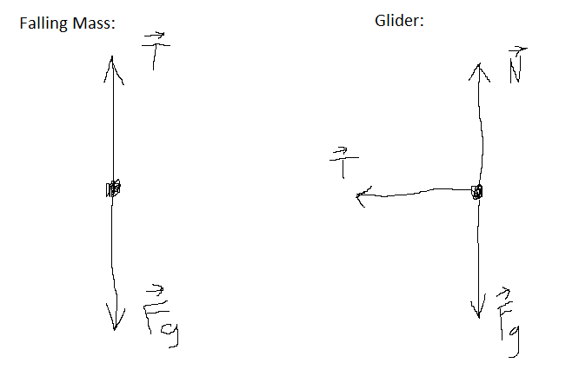We can see the force of gravity is acting on both objects, but only the glider has a normal force. We can further see the tension force acts straight up on the falling mass, while it acts on the side of the glider. We can come to the conclusion that the falling mass moves up and down, while the glider moves left and right.

**Procedure**

In this experiment we are provided with the following resources, an Apple Mac computer, the software Capstone, motion sensor, air track, pulley, 4 cylindrical masses, a 10 and 20 gram falling mass and the glider mentioned in the introduction. The cylindrical masses are to be fitted on the glider and the falling masses are to be swapped out to explore how changing the mass of each element affects the acceleration of each mass. The purpose of the air track is to create a friction-less environment for the glider to slide upon. The pulley and wire are also set up to be of no significance to the experiment. The glider is also fitted with a large flat pane for the sensor to detect and read without any inconsistencies. The data from the sensor is fed into the software, Capstone, where we can see the position, velocity, or acceleration vs time graphs, and the quadratic curve equation described in the introduction.

To gain a better sense of our experiment, the real world experiment of this lab is drawn out in the following photo. 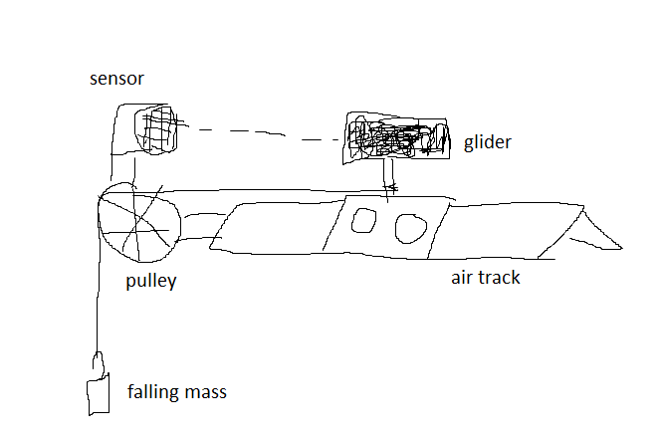Though it is not exact it should provide a meaningful insight of how things are done,

**Results**

The following table is a compilation of each setup and their masses, with the acceleration we predicted, the average acceleration from 5 trials each. We also calculated the uncertainty of the mean from our trials to gain a better understanding of the accuracy of our trials. Acceleration is recorded as a negative, because as the glider got closer to the sensor, the recorded position got closer.

|  |  |  |  |  |
| --- | --- | --- | --- | --- |
| Data Set | Predicted Acceleration $$\left(m/{s^{2}}\right)$$ | Average Acceleration $$\left(m/{s^{2}}\right)$$ | Uncertainty of the Mean $$\left(m/{s^{2}}\right)$$ | Compatible Between Predicted and Actual? |
| First Setup  (403.3g glider,  10g falling mass) | -0.237 | -0.196 | 0.0156 | No |
| Second Setup  (403.3g glider,  20g falling mass) | -0.463 | -0.416 | 0.0414 | No |
| Third Setup  (204.4g glider,  10g falling mass) | -0.457 | -0.403 | 0.0309 | No |
| Fourth Setup  (403.3g glider,  10g falling mass) | -0.237 | -0.238 | 0.0033 | Yes |

**Discussion**

After calculating the uncertainty of the mean it’s quite apparent that our predictions and average readings are not compatible (except for the final setup). Though it’s not directly apparent on what specific factor creating these inconsistencies, we theorize it’s a combination of little factors. From switching which person records the data, the string length changing when each mass is changed out, and general inconsistent readings from the sensor, they happened to create enough inconsistencies for the data to not be compatible with our predictions. In any future repeat experiments, some measures could be taken to ensure the data is more compatible. From ensuring string length is the same, to keeping one lab partner on recording data, and setting up each configuration. We could also conduct more trials per setup, where 5 could not be enough to give a consistent enough average acceleration.